Autonomous System | Autonomous System Number
- An Autonomous System (AS) is a group of networks under a single administrative control which could be an Internet Service Provider (ISP) or a large Enterprise Organization.
- An Interior Gateway Protocol (IGP) refers to a routing protocol that handles routing within a single autonomous system.
- IGPs include RIP, IGRP, EIGRP, and OSPF. An Exterior Gateway Protocol (EGP) handles routing between different Autonomous Systems (AS). Border Gateway Protocol (BGP) is an EGP. BGP is used to route traffic across the Internet backbone between different Autonomous Systems.
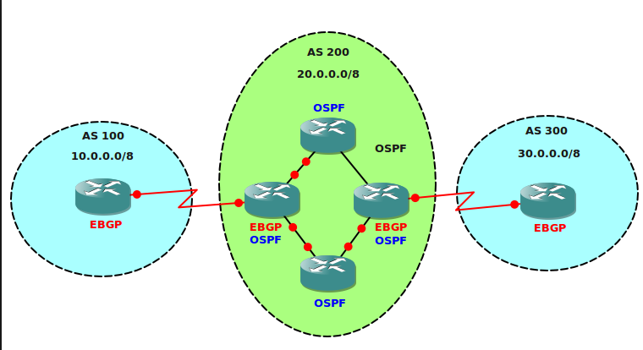
- When BGP (Border Gateway Protocol) was at development and standardization stage, a 16-bit binary number was used as the Autonomous System Number (ASN) to identify the Autonomous Systems. 16-bit Autonomous System Number (ASN) is also known as 2-Octet Autonomous System Number (ASN). By using a 16 bit binary number, we can represent (2 ¹⁶) numbers, which is equal to 65536 in decimals.
- The Autonomous System Number (ASN) value 0 is reserved, and the largest ASN value 65,535, is also reserved. The values, from 1 to 64,511, are available for use in Internet routing, and the values 64,512 to 65,534 is designated for private use.

